ADFS 2.0 Application Director Blueprint Deployment Guide

Introduction:
Active Directory Federation Service (ADFS) is a software component from Microsoft that allows users to use single sign-on (SSO) to authenticate to multiple web applications which may be located across organization boundaries.
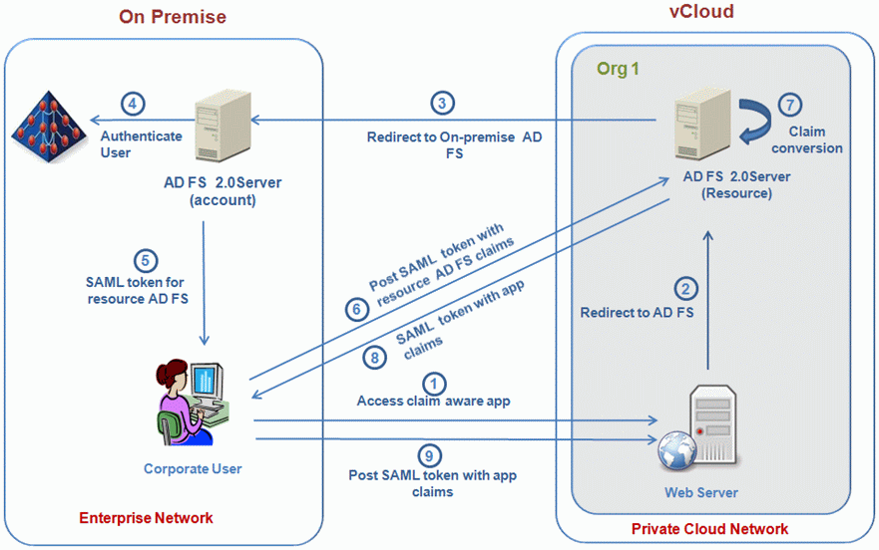

As shown in the diagram above, identity federation is established between two organizations by establishing trust between two security realms. A federation server on one side (the Accounts side) authenticates the user through the standard means in Active Directory Domain Services and then issues a token containing a series of claims about the user, including its identity.

On the other side (the Resources side), another federation server validates the token and issues another token for the local servers to accept the claimed identity. This allows a system to provide controlled access to its resources or services to a user that belongs to another security realm without requiring the user to authenticate directly to the system and without the two systems sharing a database of user identities or passwords.

The solution presented here deploys an Application Director Blueprint for an ADFS 2.0 service that is typically located in a private VMware vCloud. It assumes that the account side of the configuration already exists and is accessible to the resource ADFS that is being deployed.

Deployment Environment:
The deployment of this blueprint assumes the following are already setup and accessible to the resource ADFS that is being deployed.
- Active Directory
- Account ADFS
- Optional webserver (resource)

A separate document details the steps required for setting up these in a lab environment to test the successful deployment of the resource ADFS.

Requirements:
To complete all the steps in this guide, your lab must have a virtual machine (VM) that meets the minimum requirements specified in the following table.

Components | Requirements
Operating system | Windows Server 2008 Enterprise or Windows Server 2008 R2 Enterprise
Processor | 2 gigahertz (GHz) or higher CPU speed
Memory | 2 gigabytes (GB) of RAM or higher
Disk drive | 10 GB or more of available space

Prerequisite Software:
The following table provides details about the required software, which actions to take with the software, the reasons why the software is required, and links to download for the software.

Required software | Action | Description
AdfsSetup.exe | Download the ADFS2.0 installer from Microsoft website and place on a local http/ftp server. | AdfsSetup.exe (23.9MB)
Download: | RTW\W2K8\x86\AdfsSetup.exe http://www.microsoft.com/enin/download/details.aspx?id=10909&hash=lgsEoSLIGtGBCJOkKvquiVPJrMKZjaJ0gTN0GV0NbtWtmrL3I99XTZt05fCeFCzYSj8sr%2fJsRSDCvqYHI8V1SA%3d%3d
Microsoft .NET Framework 3.5 Service Pack 1 (SP1) | Download and install. | Windows Server 2008 Service Pack 2 (SP2): you must install this software before you install AD FS 2.0 or WIF.  Windows Server 2008 R2: it is not necessary to download or install this software as it is already present and is installed automatically.
Download : | .NET Framework 3.5 Service Pack 1  http://go.microsoft.com/fwlink/?linkid=118079
jre-1.6.0_31-win64.zip | Download and unzip | JAVA JRE
Download : | SSH: darwin_user @ <application director appliance> /home/darwin/tcserver/darwin/webapps/darwin/agent
vmware-appdirector-agent-bootstrap-windows_5.0.0.0.zip | Download and zunip | Application Director bootstrap agent
Download : | SSH: darwin_user @ <application director appliance> /home/darwin/tcserver/darwin/webapps/darwin/agent
ADFSAutomation.zip | Download and unzip into VM template | ADFS Automation files
Download : | https://raw.github.com/igate/vsx/ADFS/ADFSAutomation.zip
com.igate.automation.adfs.package | Download and import into VMware Orchestrator | VMware Orchastrator workflows and actions import package file.
Download : | https://raw.github.com/igate/vsx/ADFS/com.igate.automation.adfs.package

Open Source Components

The following open source components need to be downloaded and the corresponding JAVA jar files placed in the lib folder after extracting the ADFSAutomation.zip archive in the VM Template.

Apache Axis
Download axis-bin-1_4.zip from http://archive.apache.org/dist/ws/axis/1_4 and copy all the files to the lib folder. Do not copy the log4j.properties file provided in this zip file.
axis-ant.jar
axis.jar
commons-discovery-0.2.jar
commons-logging-1.0.4.jar
jaxrpc.jar
log4j-1.2.8.jar
saaj.jar
wsdl4j-1.5.1.jar

These are provided under the Apache CDDL license v1.0.

Mail & Activation
Download activation-1.1.jar and mail-1.4.jar from
http://grepcode.com/snapshot/repo1.maven.org/maven2/javax.activation/activation/1.1
http://grepcode.com/snapshot/repo1.maven.org/maven2/javax.mail/mail/1.4

These are provided under the CDDL license v1.0.

A full copy of the above licenses can be found in the license folder of ADFSAutomation.zip

Template Configuration:
- Create Virtual Machine Template:
OS: windows server 2008 R2 Enterprise
RAM: 2 GB
Hard Disk: 15 GB
CPU: 2vCPU’s

- Login to VMware vCloud Director
- Navigate to the Organization and then select Home tab.
  - Click on Build new vApp .
  - Provide the name for new vApp and then click Next.
  - Click on New Virtual Machine and then provide the information like name, computer name, memory and hard disk, confirm and click Next.
  - Select the Organization network from the drop down list and select Ip assignment from dropdown list and click Next.
  - Check the show networking details check box and click next.
  - Click Finish.
  - Navigate to Mycloud tab and right click on the vApp and then select open.
  - Right click on the virtual machine and then select Include CD\DVD from catalog.
  - Select the Windows server 2008 R2 enterprise iso image and click on Insert button. Note: - In our case we used “Microsoft Windows server 2008 R2 Enterprise” ISO image for creating the ADFS-Template.
- Power On the virtual machine and then complete the OS installation.
- Make sure the Administrator password contains only alphanumeric characters.
- Allow remote desktop connections to the VM.
- Installing Vmware Tools.
  - After OS Installation, right click on the virtual machine and click on “Install Vmware tools”
  - Login into the virtual machine and open the computer. Double click on the VMware Tools installer and then perform the required steps for installation.
- Restart the virtual machine and then perform the following steps.

- Install AppDirector Agent

- SSH to VMware vFabric Application Director
- Login as the darwin_user user
- Switch to the superuser using su –
- Navigate to /home/darwin/tcserver/darwin/webapps/darwin/agent
- Copy the following two files to the VM template
vmware-appdirector-agent-bootstrap-windows_5.0.0.0.zip
jre-1.6.0_31-win64.zip

- Extract jre-1.6.0_31-win64.zip to C:
- Click the start button and right click the computer icon.
- Select Properties > Advanced System Settings > Advanced tab > Environment variables.
- Click New button to create new variable called JAVA_HOME under System variables list section.
- Provide the variable name “JAVA_HOME”, then set the variable value to
C:\jre-1.6.0_31-win64 and click OK.
- Append the PATH environment variable with C:\jre-1.6.0_31-win64\bin and click OK.
- To verify the JAVA installation open a PowerShell window and run
java –version
- Extract vmware-appdirector-agent-bootstrap-windows_5.0.0.0.zip
- Inside the extracted folder run the batch file install.bat password
- Click start → run → services.msc and open the properties for the VMware vFabric Application Director agent bootstrap service.
- On the Log-On tab select the .\darwin user and enter the same password specified when running the install.bat script.
- Save and exit, Open a PowerShell command window and type
net start AppDAgentBootstrap to verify that the service starts successfully.
- Stop the service and delete the agent log file in
C:\opt\vmware-appdirector\bootstrap.log
- The zip files can also be deleted now.

- Install ADFSAutomation Files

- Extract the ADFS Automation zip package (ADFSAutomation.zip) file in C:
- Verify the following folder structure is present
C:\ADFSAutomation
C:\ADFSAutomation\lib
C:\ADFSAutomation\log4j-config
C:\ADFSAutomation\logs
C:\ADFSAutomation\license
- The following files should be present in each of the folders
C:\ADFSAutomation\lib
ADFSAutomation.jar
vsowebservice.jar
activation-1.1.jar
axis-ant.jar
axis.jar
commons-discovery-0.2.jar
commons-logging-1.0.4.jar
jaxrpc.jar
saaj.jar
wsdl4j-1.5.1.jar
log4j-1.2.8.jar
mail-1.4.jar
C:\ADFSAutomation\Log4j-config
log4j.properties
C:\ADFSAutomation\logs
<empty>
C:\ADFSAutomation\license
Apache CDDL License.txt
CDDL License.txt
- Set the ADFSAutomation_HOME environment variable to point to the extracted folder.
e.g. ADFSAutomation_HOME = C:\ADFSAutomation

- Sharing Options

- Enabling the sharing options for different network profiles.
  - Click Start, point to Control panel and then select Network and Internet.
  - Click Network and Sharing Center and then select Change Advanced Sharing setting.
  - Click Home or Work then select the Turn On file and printer sharing radio button under File and printer sharing section, after that for saving click on save changes button.
  - Click Public (Current profile) and then select Turn on file and printer sharing radio button under File and printer sharing section, and then save changes.

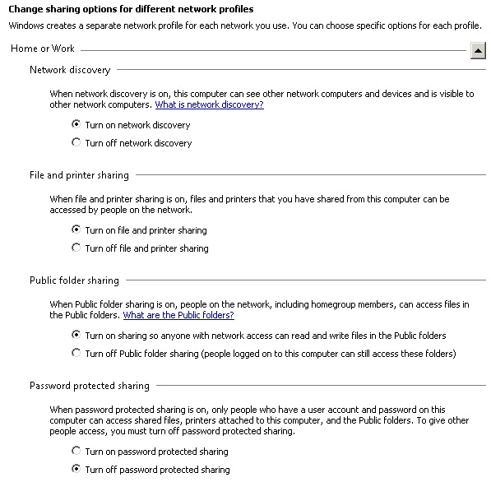

- Configure WinRM service on the template to allow remote PowerShell by running the following command C:\> winrm quickconfig
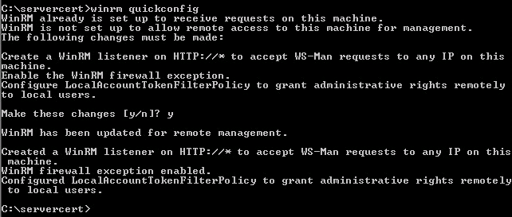
- Log off from the VM
- Right click on the vApp and select properties → starting and stopping VM’s, then set the stop action as shutdown for the VM. Save and Shut down the vApp.
- Right click on the virtual machine in vCloud and select properties then verify the “Guest Customization” options.
Note: All the Guest Customization options should be disabled under all the sections like General, Password reset, and Join Domain.
- Right click on the vApp and then select Add to Catalog. Provide the name for template and click OK.

VMware Orchestrator Configuration
- VCO ADFS Automation package import

All ADFS automation workflows and their actions are packaged in a package named “com.igate.automation.adfs.package”.
Packages are the vehicle for transporting content from one Orchestrator server to another.

This needs to be downloaded from https://raw.github.com/igate/vsx/ADFS/com.igate.automation.adfs.package

To import ADFS automation package in your orchestrator follow these steps.

- In the Orchestrator client, click on the Packages view.
- Click the menu button in the title bar of the Packages list and select “Import Package”
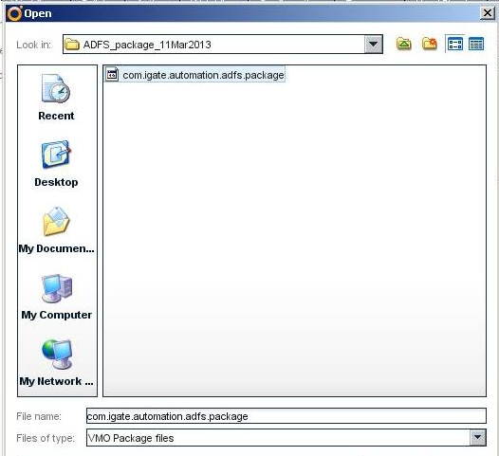
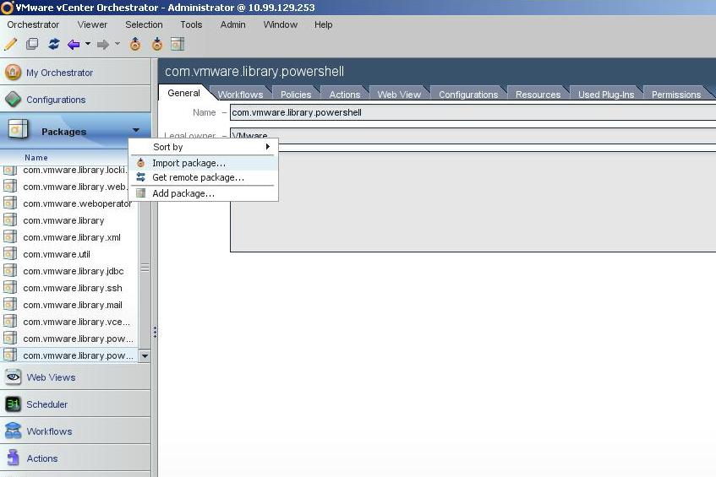

- It displays package details, click on the “Import” button as shown below.
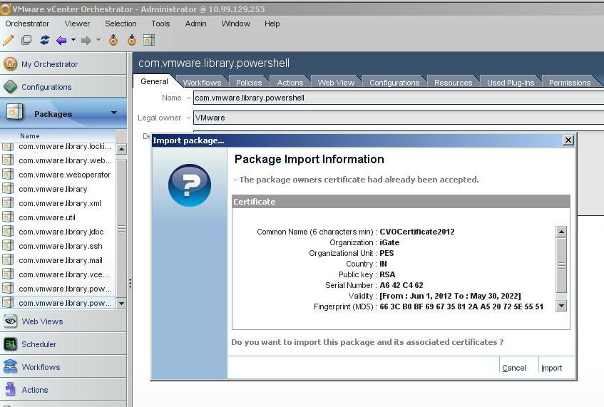

- Now it displays package contents going to be imported, click on “Import checked contents”
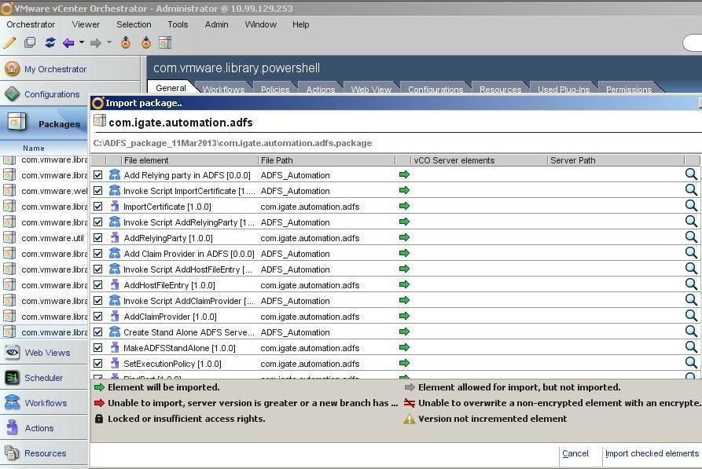

- On successful import, VCO displays the package list and its content (workflows and actions) visible in their respective views.
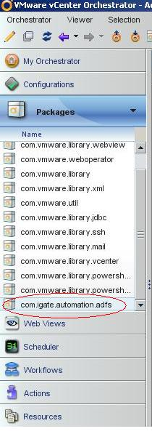 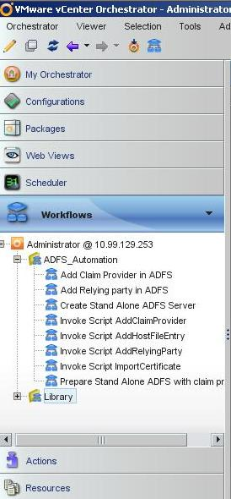 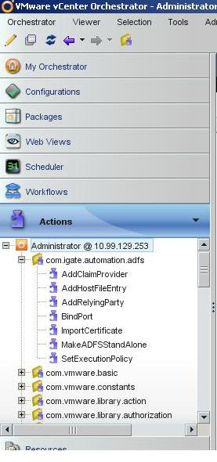

In addition to the ADFS Automation package, the VCO Powershell plugin (VMware vCenter Orchestrator Powershell Plug-in 1.0) is also required.

This can be downloaded from the VMware website at https://my.vmware.com/web/vmware/details/vco_powershell_plugin_1_0/dHRAYnRAZHdiZHAlJQ
o11nplugin-powershell-1.0.0-176.vmoapp
File size:13M
File type: .vmoapp
Release Date:2011-12-08
Build Number:176

VMware vCenter Orchestrator Powershell Plug-in 1.0
MD5SUM:8c33008641b7ffc76fee18c568c537a2 SHA1SUM:664a6885e44284e72d00b394ed6bee7baacfe692

Be sure to read the VCO documentation on how to install the plugin.

Application Director Configuration
Download and import the ADFS blueprint from solution exchange using either the “try now” link or using the darwin-cli tool. Detailed information on how to use this tool is available in the VMware vFabric Application Director user guide.

After the blueprint has been imported login to the Application Director UI and verify that all the components (custom task, service and blueprint) have been properly imported.

First step is to map the logical template to the cloud template that was created and added to the vCloud Director catalog earlier.

Browse to tasks and edit the custom task properties for ADFS_Configure and enter the values as per your environment.
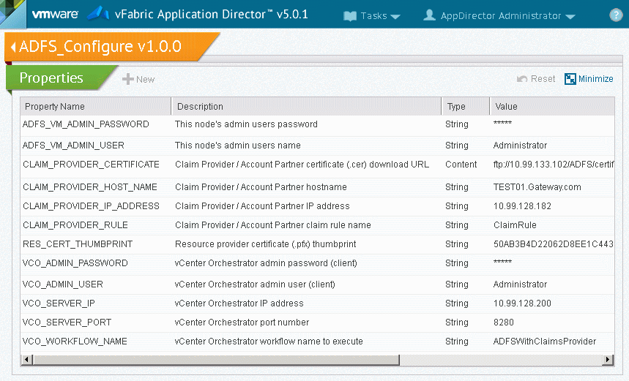

Next update the properties of the “Join Domain” custom task.
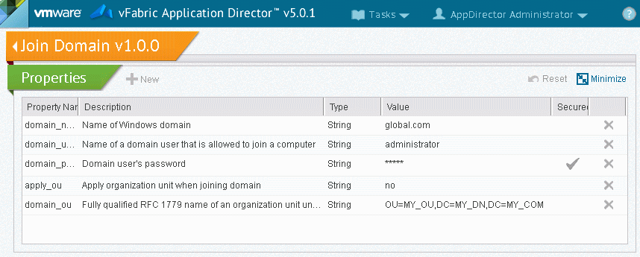

Now browse to catalog and edit the properties for the ADFS service as per your environment
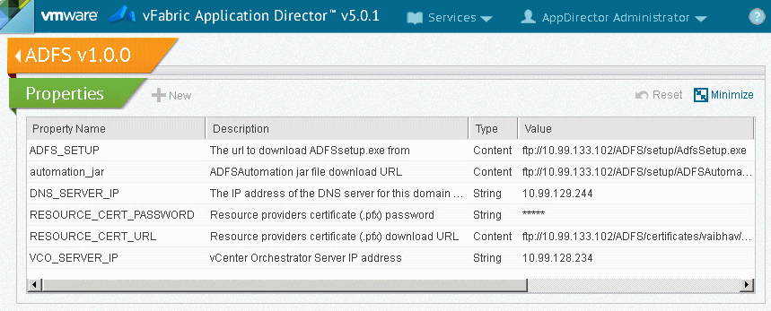

Next edit the imported blueprint and verify that the hostname of the node is set appropriately.
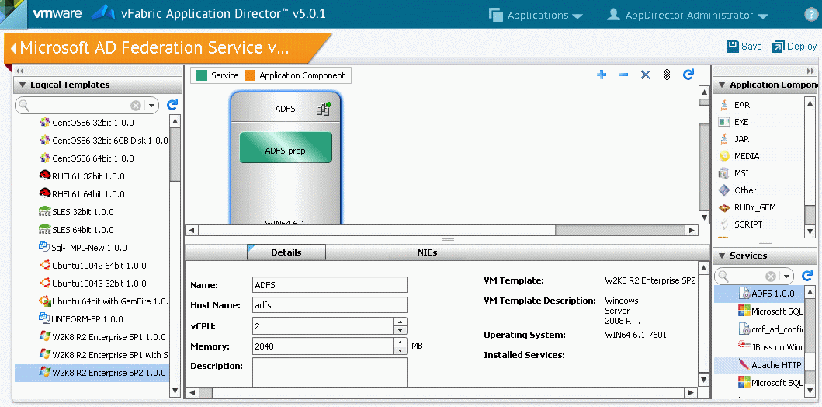
Deploy the blueprint by creating a deployment profile. Map the logical template and network to the cloud template and network and click next.

Proceed to the execution plan and add the custom tasks as shown below.
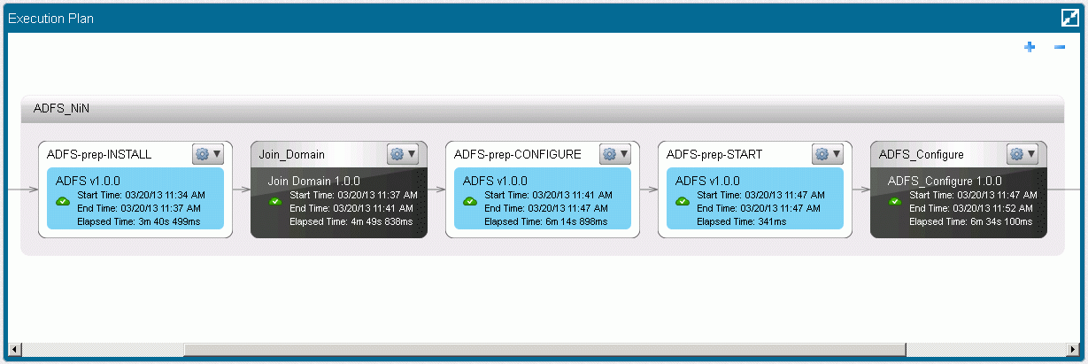
Finally click on deploy to deploy the blueprint.

Properties explained
Service Properties
Property | Description
automation_jar = ftp://192.168.10.100/ADFS/certificates/vaibhav/Automation.jar  [Type = Content] | This can be left blank, it is used to specify a URL from which to download an updated automation jar file if provided one
ADFS_SETUP =  ftp://192.168.10.100/ADFS/setup/AdfsSetup.exe  [Type = Content] | This property points to the URL where the ADFS setup file is located for direct use by the blueprint.
VCO_SERVER_IP =  10.99.128.234  [Type = String] | The IP address of the vCenter Orchestrator server where the ADFS automation package has been imported.
DNS_SERVER_IP =  10.99.133.125  [Type = String] | The IP address of the active directory server that is to be federated. This assumes the DNS server IP and AD server IP are the same.
RESOURCE_CERT_URL =  ftp://192.168.10.100/ADFS/certificates/adfs_selfsigned.pfx  [Type = Content] | The resource ADFS .pfx certificate file. Make sure the certificate subject matches the FQDN of the adfs server to be deployed.
RESOURCE_CERT_PASSWORD =  secret  [Type = String] | The password for the resource ADFS certificate.

Join Domain custom task
Property | Description
domain_name =  global.com  [Type = String] | The domain name that is to be federated, this node will be joined to the domain specified.
domain_user =  Administrator  [Type = String] | The domain admin user that has rights to add this node to the domain.
domain_password =  secret  [Type = String] | The domain admin’s password
apply_ou =  no  [Type = String] | Leave this as default
domain_ou =  OU=my_ou,DC=my_dc,DC=com  [Type = String] | This is ignored if above property is “no”

ADFS_Configure custom task
Property | Description
VCO_SERVER_IP =  10.99.128.234  [Type = String] | The IP address of the vCenter Orchestrator server where the ADFS automation package has been imported.
VCO_SERVER_PORT = 8280  [Type = String] | The VCO server web service port.
VCO_ADMIN_USER = Administrator  [Type = String] | The VCO administrator user. The same user used to login using the VCO client.
VCO_ADMIN_PASSWORD = secret  [Type = String] | The VCO administrator user password
VCO_WORKFLOW_NAME =  ADFSWithClaimsProvider  [Type = String] | Leave unchanged.
CLAIM_PROVIDER_HOST_NAME =  AccountVM.techspot.com  [Type = String] | The account partner FQDN
CLAIM_PROVIDER_IP_ADDRESS = 10.99.130.191  [Type = String] | The IP address of the account partner.
CLAIM_PROVIDER_CERTIFICATE =  ftp://192.168.10.100/ADFS/certificates/accountvmtech.cer  [Type = Content] | The certificate of the account partner. The subject name of the certificate should match the FQDN of the account partner.
CLAIM_PROVIDER_RULE = ClaimRule  [Type = String] | The name to use for creating the default claim rule. Leave as is.
ADFS_VM_ADMIN_USER = Administrator  [Type = String] | The resource ADFS administrator user name
ADFS_VM_ADMIN_PASSWORD = secret  [Type = String] | The resource ADFS administrator’s password
RES_CERT_THUMBPRINT =  4E12F0D8D8D1090FC10DB75D2BE30A7C0033C606  [Type = String] | The resource ADFS certificate (.pfx) thumbprint.

Troubleshooting
In case the blueprint does not deploy successfully the following can be checked to try and identify the problem.
- Check the Application director error to identify if it is a problem with the blueprint, the template or the deployment environment.
- Check the action script logs of the blueprint for any errors.
- Login to the deployed VM and verify the account partner and other network resources are accessible.
- The ADFS automation logs can be found in the %ADFSAutomation_HOME% /logs folder.
- Login to VC Orchestrator and check the output logs of the ADFS Automation workflows.
- If the ADFS windows service fails to start or takes long to start you may need to provide more CPU/RAM to the VM so that the service startup does not time out.

Post Deployment Configuration
Once the Blueprint has been successful deployed you can check the standalone ADFS deployment by logging in to the resource ADFS VM and running the ADFS 2.0 Management console from the start menu. The navigation tree should show the trusts and claim provider that was added.

